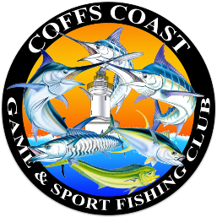
Coffs Coast Game and Sport Fishing Club
In Hours Sched Sheet
Sched Boat: |  |  |  |  |  |  | Date:
Time |  |  |  | 9:00am |  | 11:00am |  | 1:00pm |  | 3:00pm |  | Lines Up
Boat No | Boat Name | POB | Sign on time | Grid Position | Strikes | Grid Position | Strikes | Grid Position | Strikes | Grid Position | Strikes | Grid Position | Strikes | Sign off time
1
2
3
4
5
6
7
8
9
10
11
12
13
14

